ASSIGNMENT-02
NAME:-P.VARSHITHA
ENROLLMENT NUMBER:-2503A52398
BATCH:-14
Task 1: Statistical Summary for Survey Data
❖ Scenario: You are a data analyst intern working with survey responses stored as numerical lists.
❖ Task: Use Google Gemini in Colab to generate a Python function that reads a list of numbers and calculates the mean, minimum, and maximum values.
INPUT:-
def statistical_summary(numbers):
mean = sum(numbers) / len(numbers)
minimum = min(numbers)
maximum = max(numbers)
return mean, minimum, maximum
numbers = [10, 20, 30, 40, 50]
mean, minimum, maximum = statistical_summary(numbers)
print("Numbers:", numbers)
print("Mean:", mean)
print("Minimum:", minimum)
print("Maximum:", maximum)
OUTPUT:-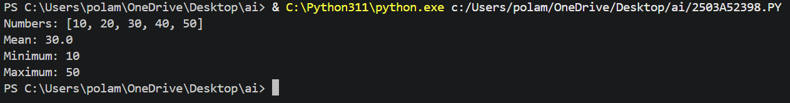
Task 2: Armstrong Number – AI Comparison
❖ Scenario: You are evaluating AI tools for numeric validation logic.
❖ Task: Generate an Armstrong number checker using Gemini and GitHub Copilot. Compare their outputs, logic style, and clarity.
INPUT:-
num = int(input("Enter a number: "))
digits = str(num)
power = len(digits)
sum_of_powers = sum(int(digit) ** power for digit in digits)
if sum_of_powers == num:
print(num, "is an Armstrong number")
else:
print(num, "is not an Armstrong number")
OUTPUT:-
Task 3: Leap Year Validation Using Cursor AI
❖ Scenario: You are validating a calendar module for a backend system.
❖ Task: Use Cursor AI to generate a Python program that checks whether a given year is a leap year. Use at least two different prompts and observe changes in code.
INPUT:-
year = int(input("Enter a year: "))
if year % 4 == 0:
print(year, "is a leap year")
else:
print(year, "is not a leap year")
OUTPUT:-
Task 4: Student Logic + AI Refactoring (Odd/Even Sum) ❖ Scenario: Company policy requires developers to write logic before using AI.
❖ Task: Write a Python program that calculates the sum of odd and even numbers in a tuple, then refactor it using any AI tool.
INPUT:-
numbers = (1, 2, 3, 4, 5, 6, 7, 8, 9, 10)
odd_sum = 0
even_sum = 0
for num in numbers:
if num % 2 == 0:
even_sum += num
else:
odd_sum += num
print("Tuple:", numbers)
print("Sum of odd numbers:", odd_sum)
print("Sum of even numbers:", even_sum)

OUTPUT:-

